## **Fokus Hub (Participant Issues)** **The ones Highlighted in yellow are the updated ones.**

Problem 1: When you’re making an account, they ask for profile details; personal, location, professional which you can fill. But when you view your profile, some of those sections (date of birth, gender, country, city, industry) that you filled in the beginning are empty/null. So you need to fill them all over again.

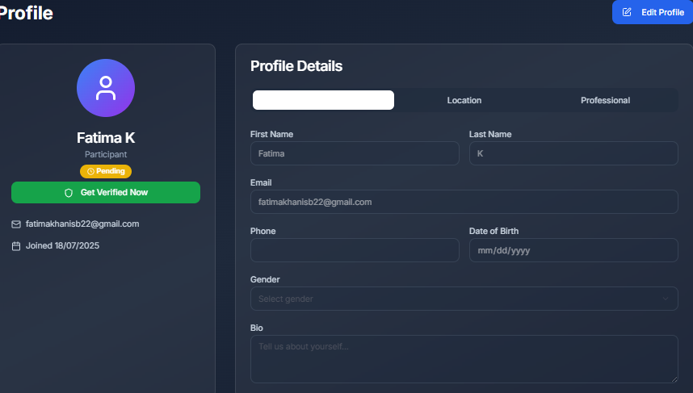

Problem 2: When you click on these, they become unable to read. Seems to be a color combination issue.

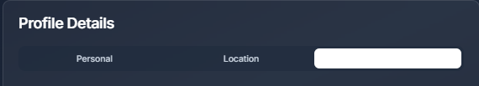

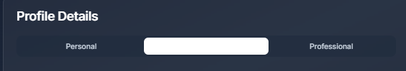

Problem 3: Dates have inconsistent formatting: "18/07/2025" should follow a single date format (DD/MM/YYYY or MM/DD/YYYY).

## 

**Problem 4:** If a user fills all the details in profile e.g name, last name, phone number, city, postal code etc. After saving changes, most of it gets erased.   
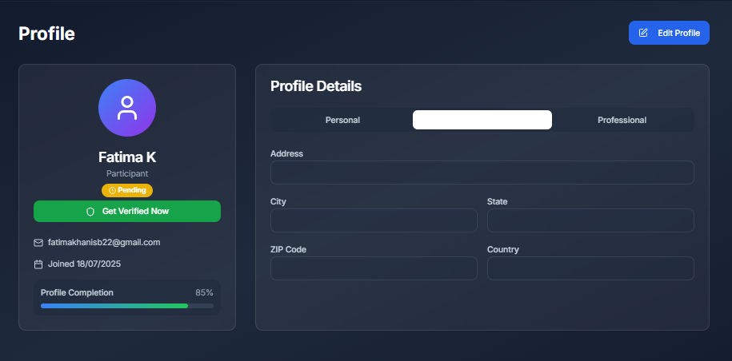  
It tells you that profile is almost complete. But most of the details you enter are all erased after saving changes. However, some options remain filled.  
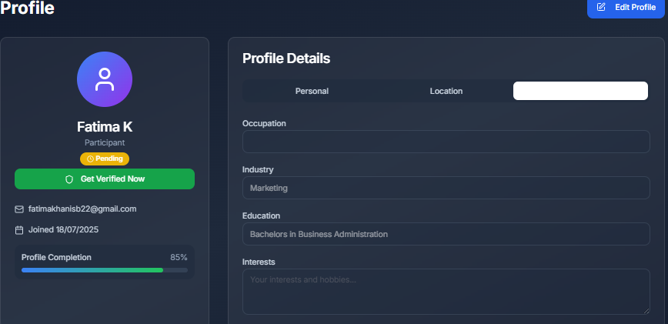

## **For the main Page:**

**Problem 1:** On the main page, the “Pricing” option does not redirect you to any pricing options when you click on it. For example, if a user clicks on “Testimonials” option, it will redirect them to the following part of the page:  
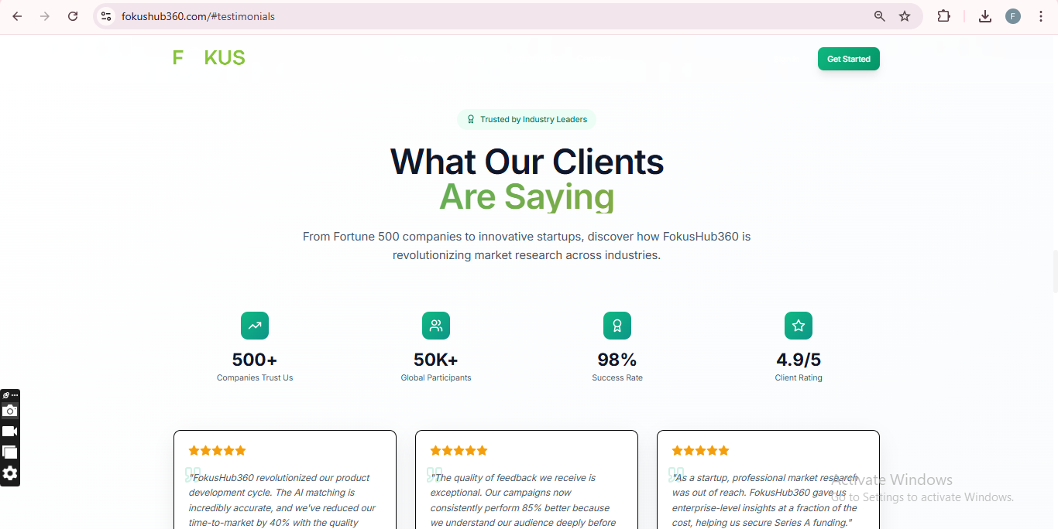  
But If they click on the “Pricing” option, nothing changes. They’ll not be redirected to the pricing options. Instead, only the URL link will change.  
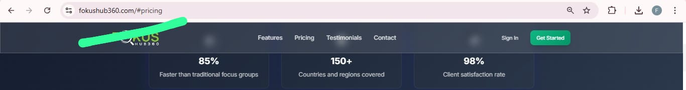

Same problem exists with the “Contact” option.

**Problem 2:** When you scroll down on the main page, the following text becomes blurry to read:  
Before Scrolling:  
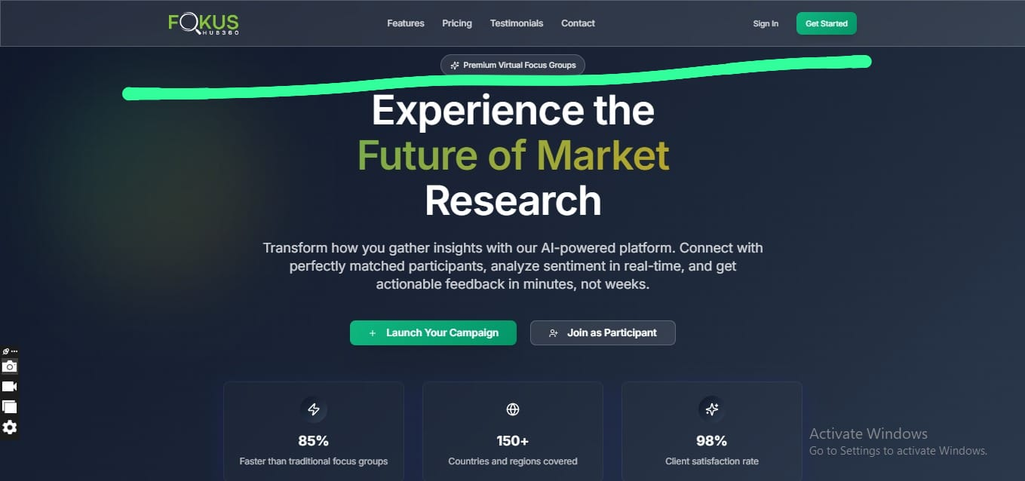

After Scrolling:  
